Effects of Posture on Arterial Blood Pressure

Nicole Kessler
Fortran/C++ For Scientists and Engineers
Dr. Crumley
Spring 2007

ACKNOWLEDGEMENTS

I would like to thank Dr. Crumley for his help and patience this semester.

ABSTRACT

This program was made to compare the different affect posture has arterial blood pressure at various points in the body. The approximate blood pressure was calculated by first collecting data about the height of different body parts from the ground. The data was then compared to the height of the heart from ground level and from there the approximate blood pressure was calculated.

PURPOSE

The purpose of this program is to calculate the approximate arterial blood pressure in different areas of the body and to observe how the approximate pressure changes with regard to posture. The two different posture positions being observed are that of a person standing upright and lying flat on the ground.
INTRODUCTION

The idea for this program came from my interest in physics and the human body. The circulator system especially interested me for this project because often times people refer to the system of arteries and veins as a system of pipes where the heart is the pump. On a simple level, in the absence of friction, Bernoulli’s equation (1), where P is the pressure, ρ is the density of the blood, and h is the height (or elevation of the blood in the vessel), can be applied to the pressure in the arteries.
P + ρgh + $\frac{1}{2}$ρv² = const (1) ²
Bernoulli’s equation is based on the principle of conservation of energy. The three terms in the above equation represent the total energy in the blood. P is the pressure energy, ρgh, the gravitational potential energy, and the third term is the kinetic energy of the fluid per cubic centimeter. Thus, the energy in the blood should be conserved throughout the body. This principle yields equation (2). From (2), the second pressure is equal to (3), where v_{h} is the velocity of the blood at the heart, and v₂ = (A_{h}/A₂)v_{h}, where A is the cross-section area of the vessel.
P₁ + ρgh₁ + $\frac{1}{2}$ ρv₁² = P₂ + ρgh₂ + $\frac{1}{2}$ρv₂² (2) ²
P₂ = P₁ - ρv_{h}² [v₂² - 1] (3) ²
Using the above equations, the blood pressure of the different vessels in the body can be found where the initial pressure and velocity is that of the blood at the aorta, where the blood first exits the heart. However, blood is not as simple of a fluid as water, blood contains red and white blood cells which can complicate the amount of pressure and friction against the vessel walls. Also, the vessel walls are elastic and can expand depending on the forces applied by the blood. These factors can contribute to an energy loss and thus Bernoulli’s equation cannot be used directly. However, the walls of the arteries are stronger and not as flexible as the walls of the veins. Arteries are the vessels that carry the blood away from the heart and to the body. Veins carry the blood back to the heart and, therefore, are not under as much pressure as the arteries. As a result, the pressure drop through the main arteries, not the capillaries, is small. ¹ So if a body is lying horizontally the blood pressure in the arteries is approximately uniform, however, the blood pressure will not be uniform if a body is in the upright direction. When in an upright position, the blood pressure depends on the difference in height between the heart and the area of the body where the pressure is being measured. ¹ Once the difference in height is found, equation (4) can be used to find the approximate pressure of the body part.
P_{b} = P_{h} + ρgh (4) ²
In the above equation, P_{h} is the average blood pressure at the heart, and h is the height difference and ρ is still the density of blood. In a young healthy human being, the average blood pressure at the heart is 100 mmHG. This average pressure comes from a systolic pressure of about 120 mmHG, and a diastolic pressure of 80 mmHG for a young, healthy human.${}^{4}$

PROGRAM

Before running the program, data was collected from various college-aged students with no know medical conditions that affect blood pressure. Data consisted of heights from the ground of different areas of the body. Data was taken at eye level, shoulders, heart, waist, hips, mid thigh, knee, mid calf, and feet when the individual was both standing and lying down. Also noted, but not included in the written file, was the individual’s overall height. Once the data was written into a file, the program could run. The program uses the average blood pressure at the heart for a young healthy individual and assumes the person’s arteries are not clogged. The program also does not take into account the expansion and contraction of the arteries (see explanation in introduction). Once running, the program opens the file and reads the data. It then calculates the height difference between the heart and the specific body part for when the individual is both standing and lying down. With the value for h, the program then calculates the approximate blood pressure for the body part, for both standing and lying, while converting from dynes per cm${}^{2}$ to mmHG. The program also prints off the specific values calculated for the pressure to the screen. After calculating the pressures for both situations, the program creates a graph that compares the blood pressure in the different areas of the body for standing and lying down. The pressures are graphed in histogram form to show that they were measured in segments and not continuously. The two plots are color-coded and labeled to distinguish them from each other. Also, the overlapping pressure at the heart is represented by a circle to make it more visible.

RESULTS/CONCLUCION
After running the program for ten different individuals, the results were mostly the same. The following are the graphs for the shortest individual, Nicole at 5’3’’, and the tallest individual, Zach at 5’9’’.

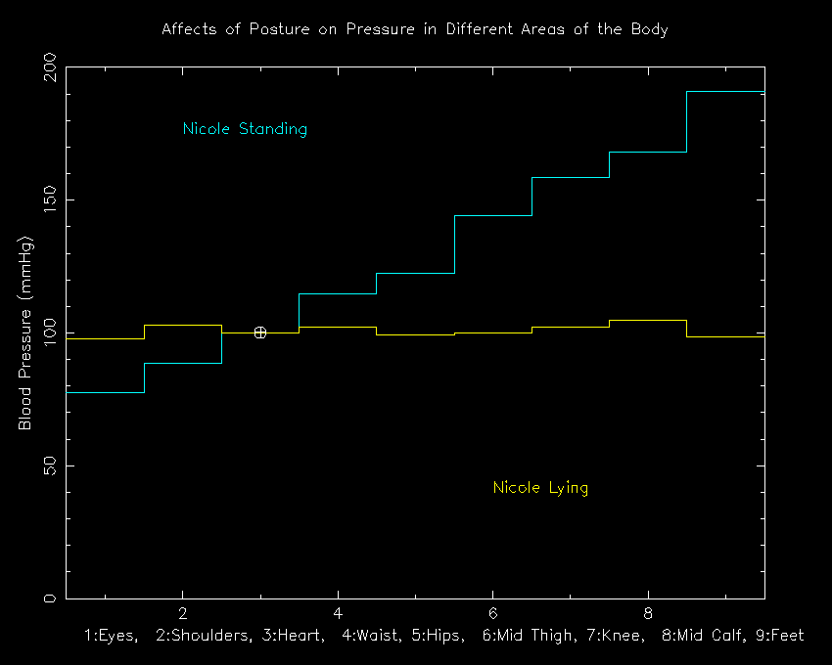 Figure 1: Approximate Arterial Blood Pressure for Nicole

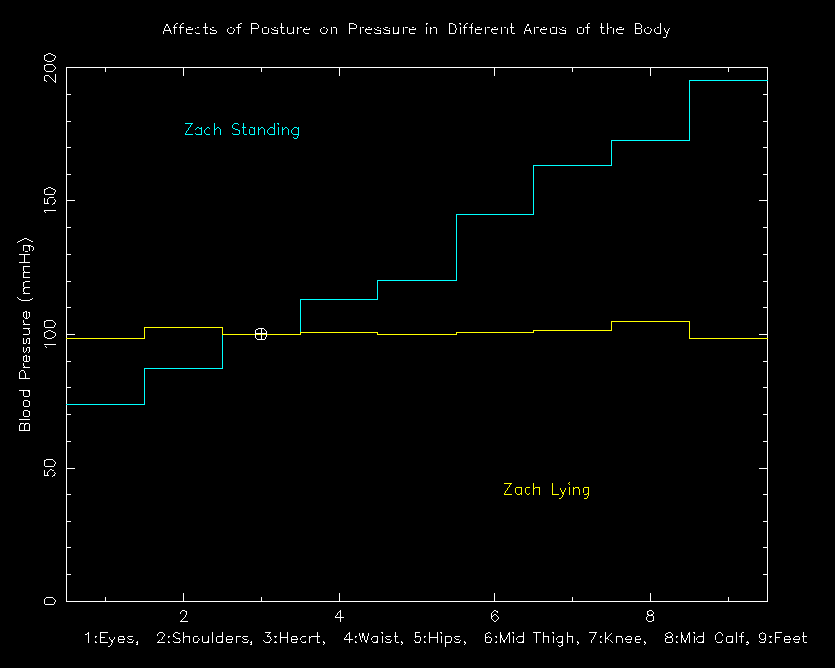
Figure 2: Approximate Arterial Blood Pressure for Zach

The plots above are very similar to each other and to the other 10 plots that were made, with only slight differences. Clearly, it can be seen that the approximate blood pressure of an individual when lying down is much more uniform that of the standing individual. Both Zach and Nicole have a very uniform spread of blood pressure throughout their bodies. The difference between the blood pressures while standing is largest at the feet; however, the difference between the changes in blood pressure at eye level is what people notice most. This pressure difference explains the lightheaded feeling a person gets when they stand up too fast. Standing up fast causes a sudden decrease in the blood pressure in the brain’s arteries, which then causes a sudden, but temporary, decrease in blood flow to the brain.² The differences between the two graphs are most obvious on the plot of the individual’s blood pressure while standing. Zach, who is six inches taller than Nicole, has a larger range of pressure throughout his body. If I were to continue using this program, I would want to take more data of taller and shorter individuals. Obviously the taller individuals will have a larger range of blood pressure when standing, and the shorter individuals, a smaller range. I would then like to look at their medical records to see if a very large or small range in approximate arterial blood pressure can affect a person’s health in any way, good or bad.

Bibliography

¹Burton, Alan C. Physiology and Biophysics of the Circulation. Chicago: Year Book
Medical Publisher, Inc., 1965.

²Davidovits, Paul. Physics in Biology and Medicine. Englewood Cliffs: Prentice-Hall,
Inc., 1975.

³Green, Jerry Franklin. Fundamental Cardiovascular and Pulmonary Physiology: An
Integrated Approach for Medicine. Philadelphia: Lea & Feniger. 1982.

⁴Marieb, Elaine N. Human Anatomy and Physiology. 6th ed. San Francisco: Pearson
Education, Inc., 2004

⁵Taber, Larry A. “An Optimization Principle for Vascular Radius Including the Effects of
Smooth Muscle Tone.” Biophysical Journal. 74 (1998): 109-114.

⁶Vogel, Steven. Vital Circuits: On Pumps, Pipes, and the Working of Circulatory
Systems. New York: Oxford University Press, 1992.

